**“HO TEL MANAGEMEN SYSTEM”**

Course Tittle:-Software Development Capstone Project

Course Code:- SE133

Submission Date:-10/12/2018

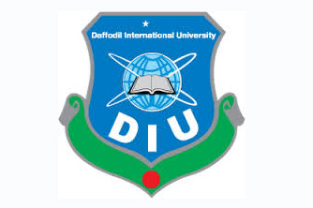

**Submission To**

Name: Nur Mohammad Rayhan

ID: 181-35-2361

Section: B

Department of Software Engineering

Daffodil International University

K.M Imtiaj-Ud-Din

Assistant Professor

Department of Software Engineering

Daffodil International University